Case Study 2:

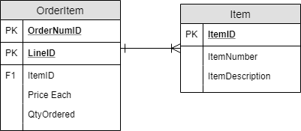

Case Study 3:

1. 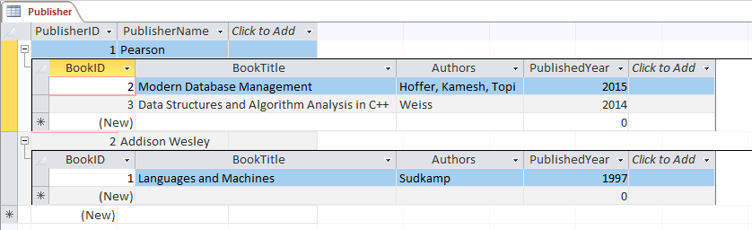

2. This database is in 0NF because there can multiple values for the Authors field. We would need to make the following tables: AuthorID with AuthorName, AuthorBookID with AuthorID and BookID, PublisherAuthorID with PublisherID and AuthorID. This would get rid of any transitive dependencies.

Part 2 (VidCast):

